AI Arena 2026
Track 1 – AI on Embedded Systems

Traffic Sign Recognition
1. Challenge Overview

Build a Deep Learning (DL) solution to recognize 16 traffic-sign+1 unknown classes from images and deploy it for embedded inference.
Frameworks: TensorFlow, Keras, PyTorch, or other suitable frameworks.

2. Task
- Create an inference application to accept 1 input image array over UART.
- Image size: 48 × 48 rgb
- Predict one of the 16 traffic-sign+1 unknown classes
- Send back predicted class id over UART.
- Run this application successfully on QEMU
- Trained model should be suitable for deployment on ESP32-S3 WROOM with Zephyr RTOS

3. Dataset
The dataset contains 16 classes+1 unknown class = total 17 classes
Final evaluation will use an unseen test dataset.
Training and validation datasets consist of these classes:

Class ID | Traffic Sign
0 | Speed limit (5 km/h)
2 | Speed limit (30 km/h)
3 | Speed limit (40 km/h)
4 | Speed limit (50 km/h)
5 | Speed limit (60 km/h)
6 | Speed limit (70 km/h)
7 | Speed limit (80 km/h)
24 | Go Right
43 | Go Right or Straight
69 | Height Limit
70 | Weight Limit
72 | Length Limit
83 | Steep Descent
84 | Steep Ascent
85 | Narrow Road
86 | Narrow Bridge
87 | Unknown
Note: Class IDs are not consecutive. The submitted solution must correctly map the model output to the official Class ID.

4. Input Requirements
- Size: 48 × 48 pixels
- Color: RGB
- Channels: 1
- Model input: 48 × 48 × 1
- Teams must use consistent preprocessing during training and inference.

5. DL Approach
- DL: Image → Neural Network → Classification
- Choose an approach suitable for accuracy and embedded resource constraints.

6. Development Flow
The challenge is divided into two phases:
- Phase 1 – Participant Development: Teams develop, train, optimize, validate, and test their solution up to QEMU.
- Phase 2 – Evaluation (DAI team): The evaluation team will deploy the submitted solution on the ESP32-S3 WROOM, run the model on hidden test dataset, and evaluate the final performance.

Participant Development Flow

Evaluation Flow

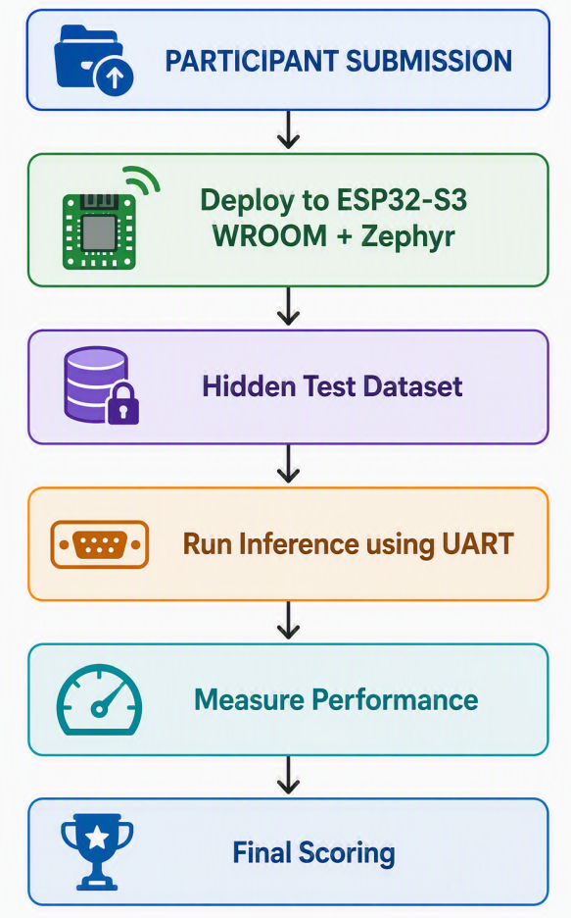

7. Model Optimization
- Apply any optimization technique suitable for embedded deployment.
- Consider: Model size, RAM usage, inference speed, and accuracy.
- The optimized model must be re-tested to verify its accuracy.

8. Documentation
Each team must provide a short PPT explaining its solution.
The presentation should cover:
1. Approach
- Which algorithm/model did you use?
- Why did you choose it?
2. Training
- How was the model trained?
- What training/validation results did you obtain?
3. Optimization
- Which optimization or quantization technique did you use?
- What was the model size before and after optimization?
- What happened to accuracy?
4. Embedded Deployment
- How did you integrate the model with Zephyr?
- How did you run it on QEMU?
5. Performance on validation set on QEMU
- Accuracy
- Model size
- RAM usage
- Inference time

9. Evaluation
Accuracy = Number of correct predictions / Total number of predictions
Category | Weight
Model Accuracy | 30%
Optimization & Quantization | 20%
Embedded Deployment (QEMU + ESP32) | 20%
Inference Performance | 15%
Code Quality & Documentation | 10%
Innovation | 5%
Total | 100%
Evaluation will use the hidden test dataset.

10. Submission Package
Your submission folder should contain:
├── src/
│ ├── model_training.py
│ ├── model_optimize.py (if used)
│ └── qemu_app/
├── model/
│ ├── trained_model
│ └── quantized_model
└── documentation/
└── Solution_Documentation.pptx
└── README

The submission must contain sufficient information and code to reproduce and run the solution on QEMU.

11. Tie Breaker
If two or more teams achieve similar overall scores, preference will be given to the solution with the best embedded efficiency.
The following will be considered:
- Lowest RAM usage
- Fastest inference
- Smallest model size

-----------------

